International Seminar on

Cartography and Cartosemiotics

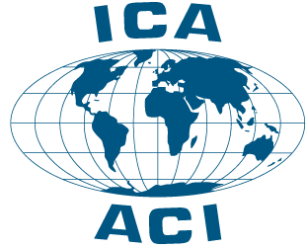 | Organized by the  ICA Commission on  Theoretical Cartography,  The Center for Cartography at Vilnius University  and  Lithuanian Cartographic Society | 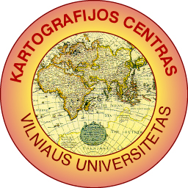

Friday, March 21st 2003 at Vilnius University
Ciurlionio 21/27 (Room 217), Vilnius, Lithuania

P R O G R A M

8:30 – 9 AM REGISTRATION
9 – 9:15 AM GREETINGS
9:15 – 10:30 AM PAPERS

- A. WOLODTSCHENKO (DRESDEN): New Cartosemiotics.
- A. ČESNULEVIČIUS (VILNIUS): Gnoseological Aspects of Geographical Space Perception by 17th and 18th Century Maps of Lithuania [in Russian].
- D. KATZ (NEW YORK/VILNIUS): Stateless Culture, Power and Cartography.
- M. DUMBLIAUSKIENĖ & P. KAVALIAUSKAS (VILNIUS): Methodology for Evaluation of the Communicative Quality of Thematic Maps (the Lithuanian experience).

10:30 – 10:45 AM COFFEE BREAK
10:45 – 12 AM PAPERS

- G. BECONYTĖ (VILNIUS): Semantic Modelling for Thematic Mapping.
6. J. PASŁAWSKI (WARSAW): Some problems of Elaboration of Maps for the Visually Impaired.
7. A. BAUTRĖNAS (VILNIUS): Color Perception in Thematic Maps [in Russian].
8. A. GORDYEYEV (KYÏV/MOSCOW): Cartosemiotics in the Nautical Cartography [in Russian].

12 – 12.30 PM POSTER SESSION AND DISCUSSIONS

POSTER PRESENTATIONS:

T.DUKSA (VILNIUS): Nautical and Aeronautical charts of Lithuania.
Z. GULBINAS (VILNIUS): Cartographic Visualisation of Applied Territorial Exploration
D.MARDOSIENĖ (VILNIUS): Official Maps of Lithuania.
J. ŠPŪRAITĖ AND M. BERNOTAITĖ (VILNIUS): Perception of Signs in Tourist and Advertizing Maps.
J.VAITKEVIČIENĖ (VILNIUS): Usability Aspects of Aeronautical Charts [in Russian].
A. WOLODTSCHENKO (DRESDEN): Kartosemiotik am Institut für Kartographie/ TU Dresden [in German and English].

12:30 – 1:30 PM LUNCH

1:30 – 2:30 PM KEYNOTE LECTURE BY DR. A. WOLODTSCHENKO: Cartosemiotics

3 – 4 PM SHORT TOUR OF VILNIUS UNIVERSITY AND ITS MAP COLLECTION

6 – 9 PM FESTIVE FAREWELL IN AN OLD CITY CAFÉ. . .

